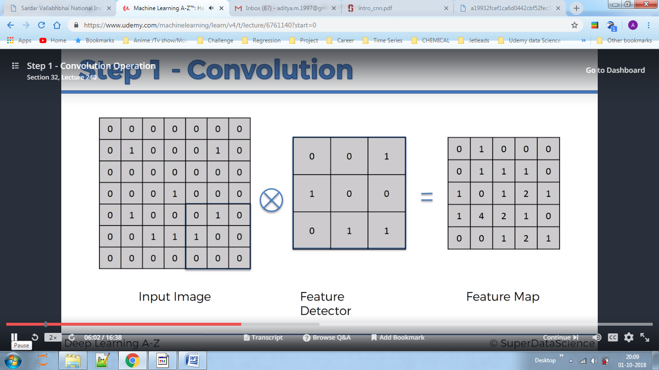

We defined a feature vector and then we multiply it by input image taking 3x3 matrix at a time,4 represents 4 ones in matrix when multiplied to a feature vector with same positions of one.Here striding is one which means how much pixel we shift everytime.If we make stride as 2 we lose some info but the objective is we are looking for feature and here we got 4 which specifies we did get a feature there.

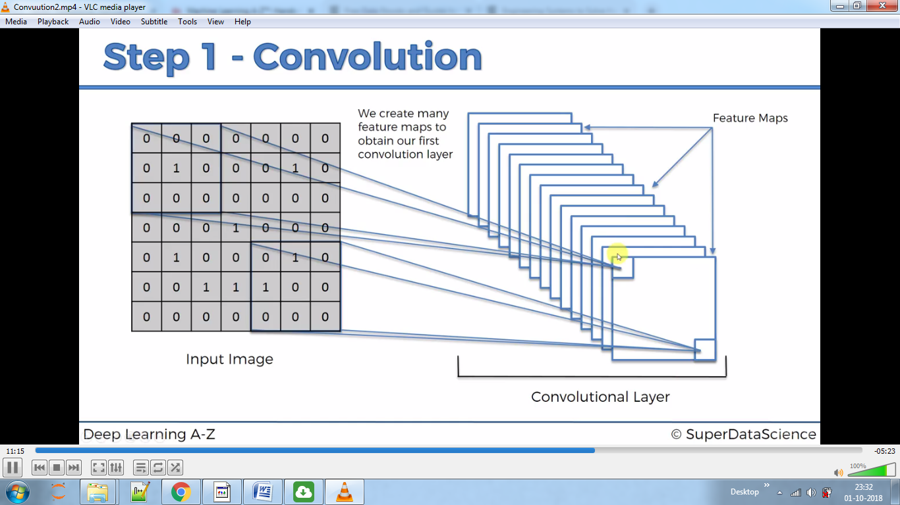

By doing this we make many feature maps, each containing some features.

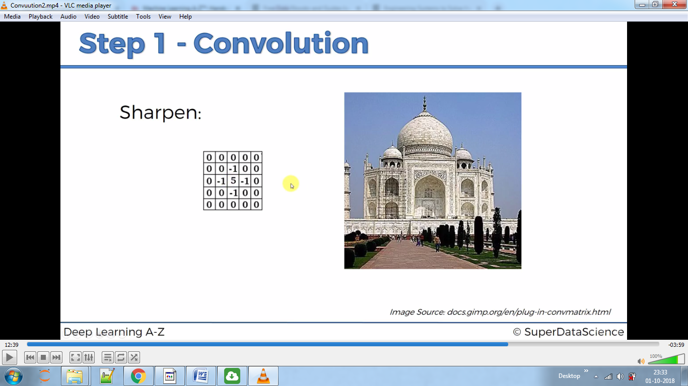

Averages above

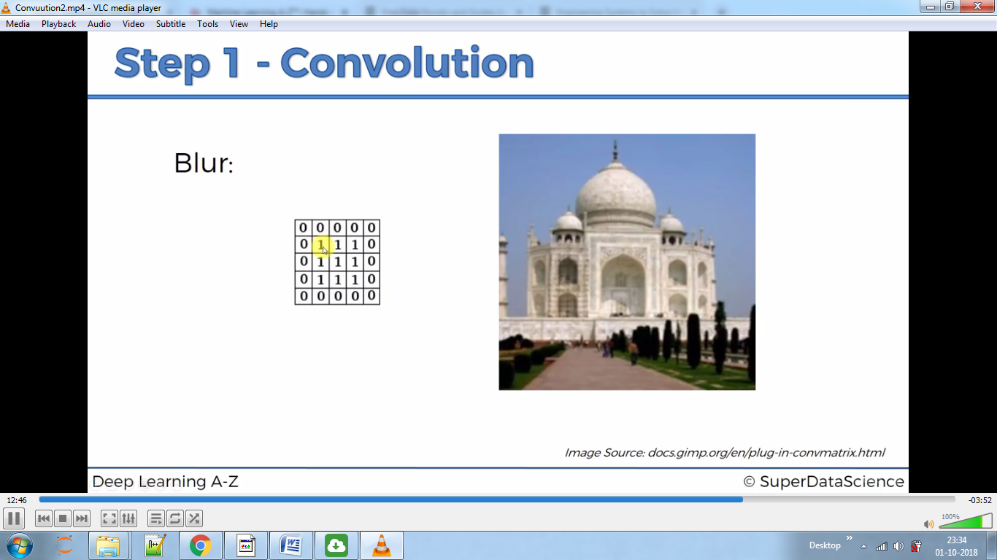

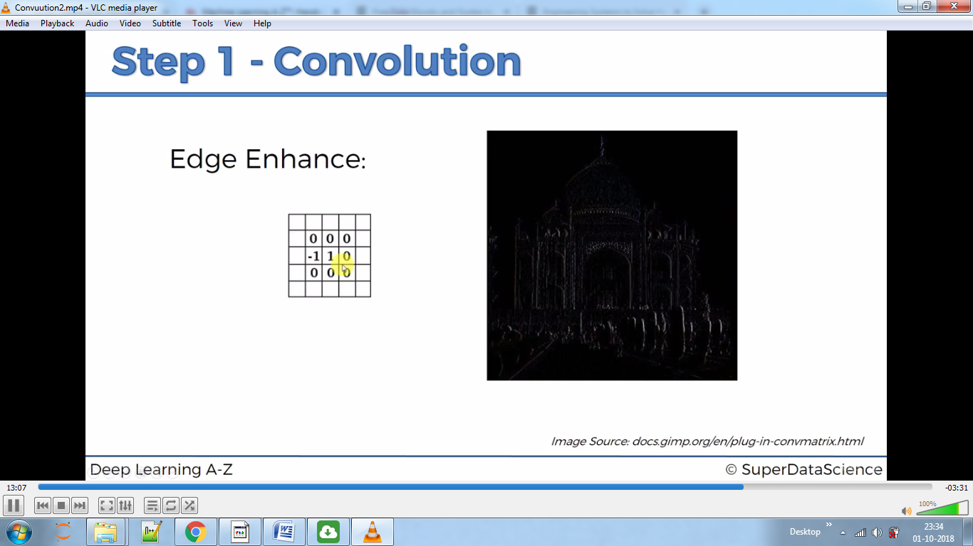

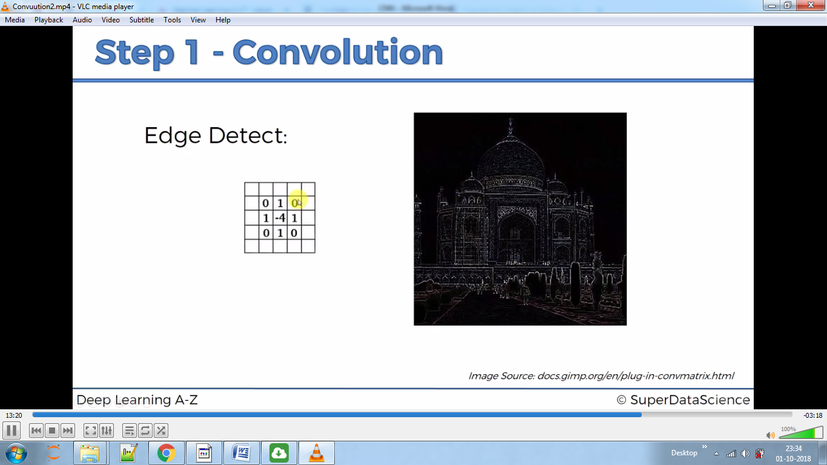

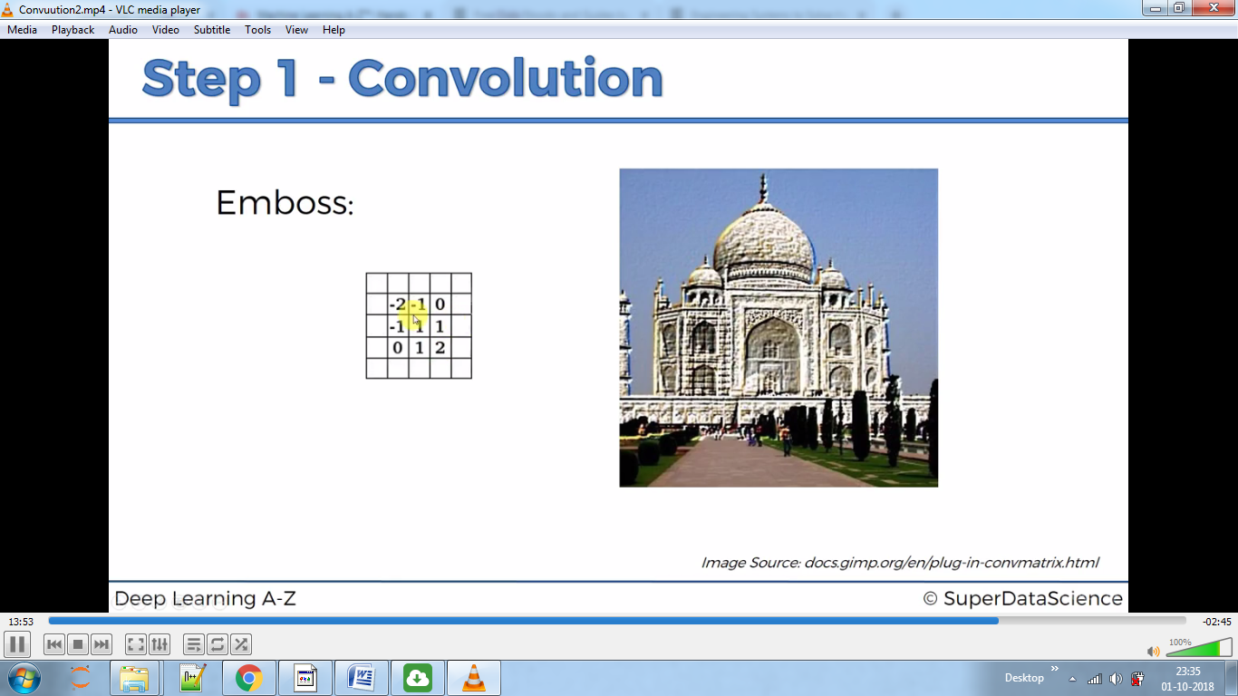

Here in above examples we chose features and output the pattern containing that feature,remember here the pattern is stored but we extract different features.

ReLU

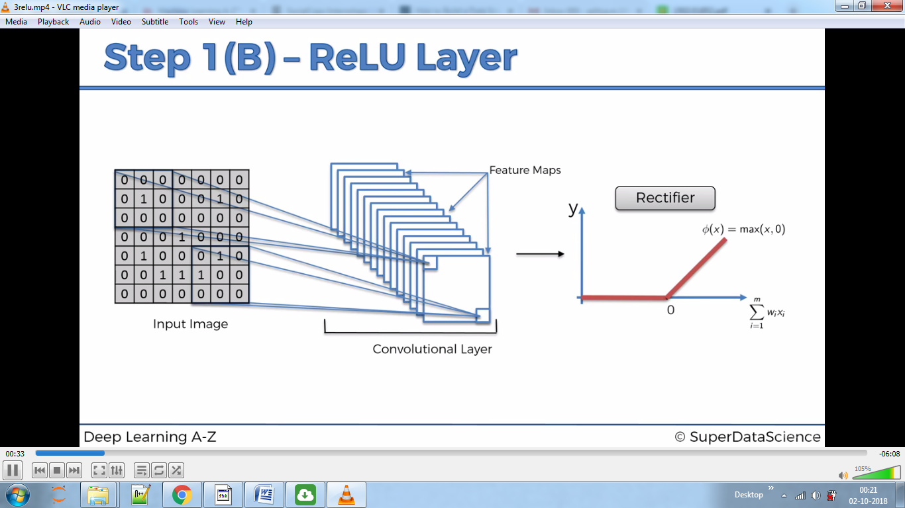

By doing this we increase Non-Linearity in our Algorithm as images mostly are non-Linear in nature.

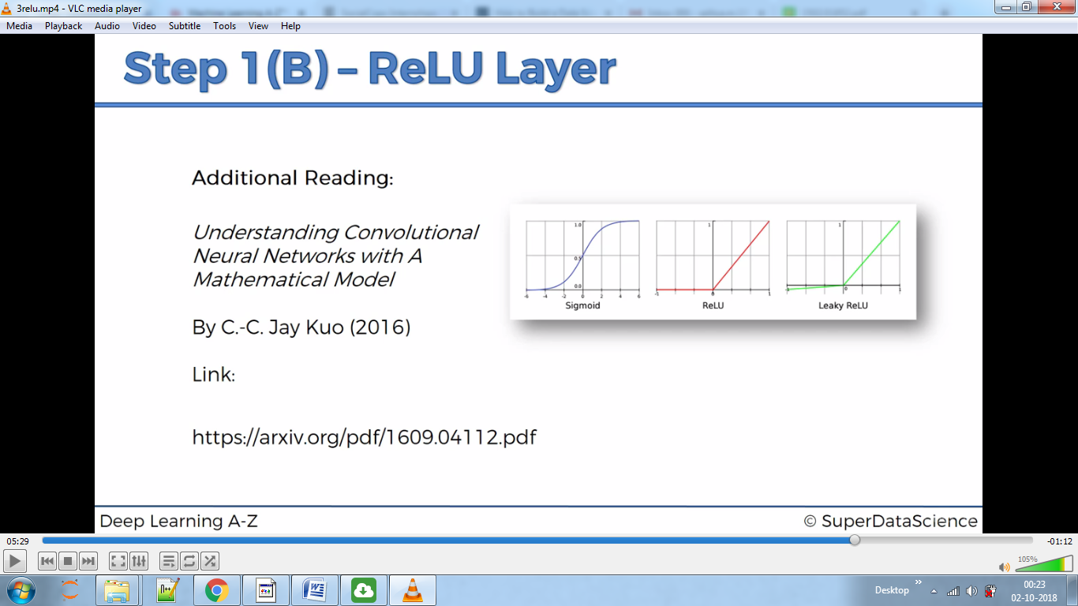

MAX-POOLING

Spatial Invariance –it doesn’t care where the cheetah is looking,or his body texture etc. ,It still should be able to find the feature .

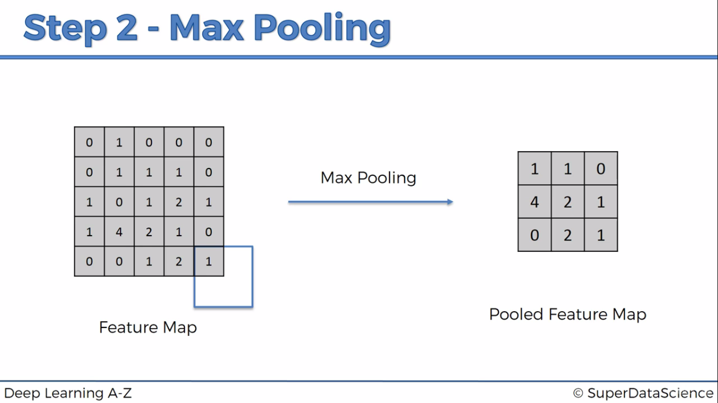

Here taking stride as 2 and then making pooled Feature map maximum number from each matrix 2x2.

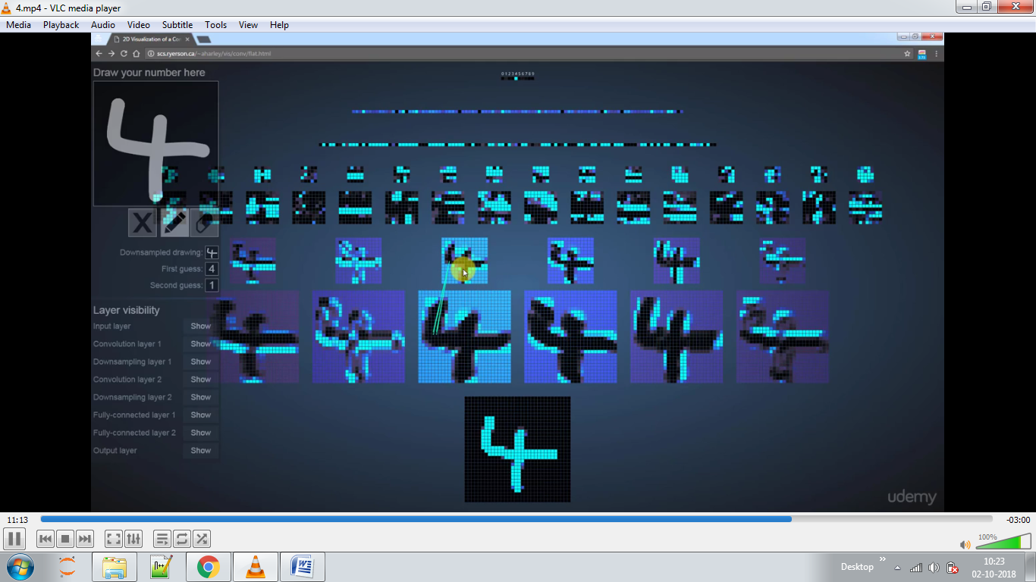

1st from bottom is input,second is convolution layer,3rd is pooled layer then it is repeated again.

FLATTENING

Rearrangement of pooling layer eg. it will rearrange above layer as 110 421 021

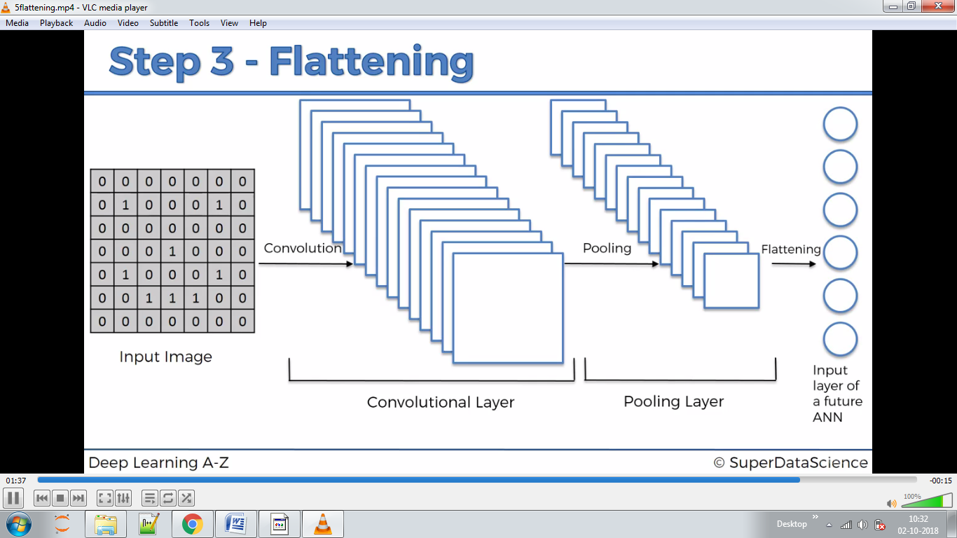

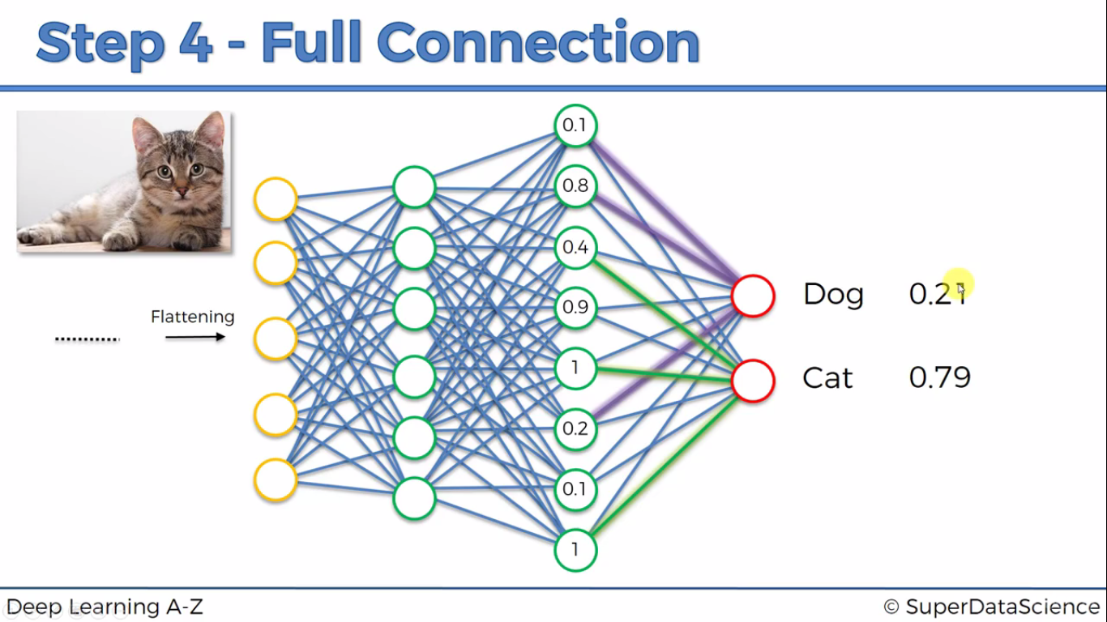

Here it detects certain features of cat by learning which bubble gives dominant features of cat,say here it will detect that 0.9,1,0.8 are features dominant in cat

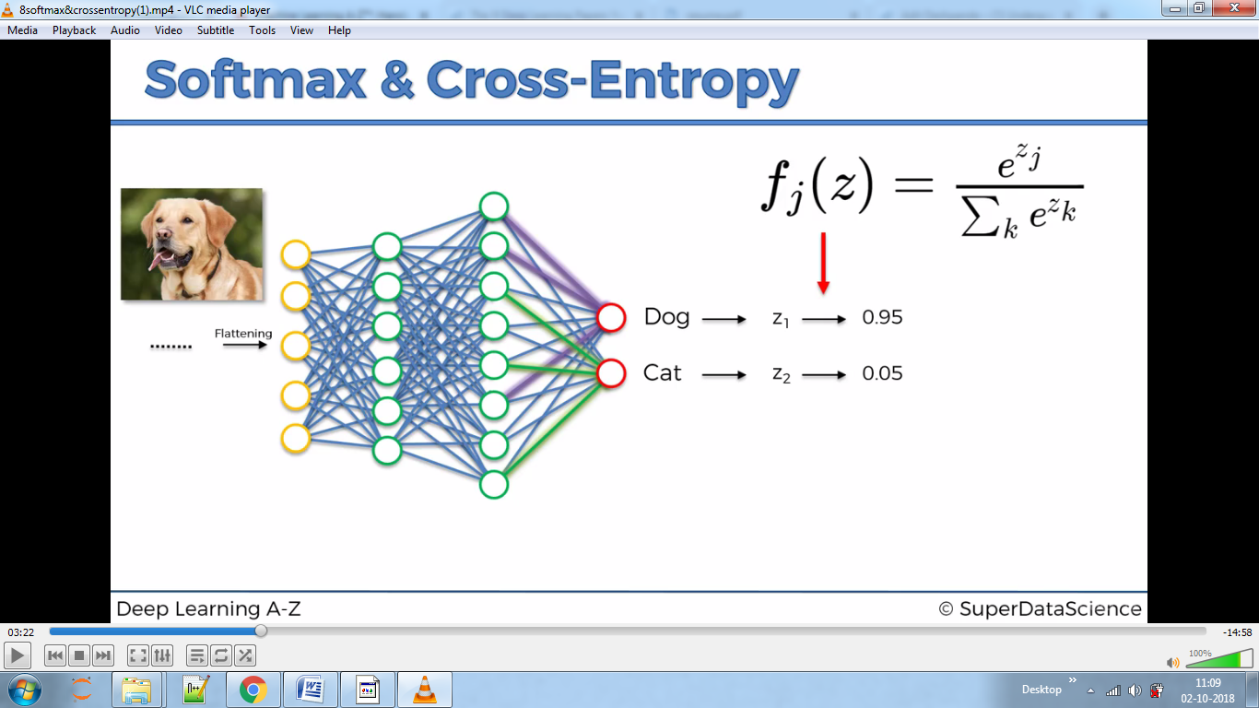

Softmax above squashes value between 0 and 1.

Cross Entropy below:-

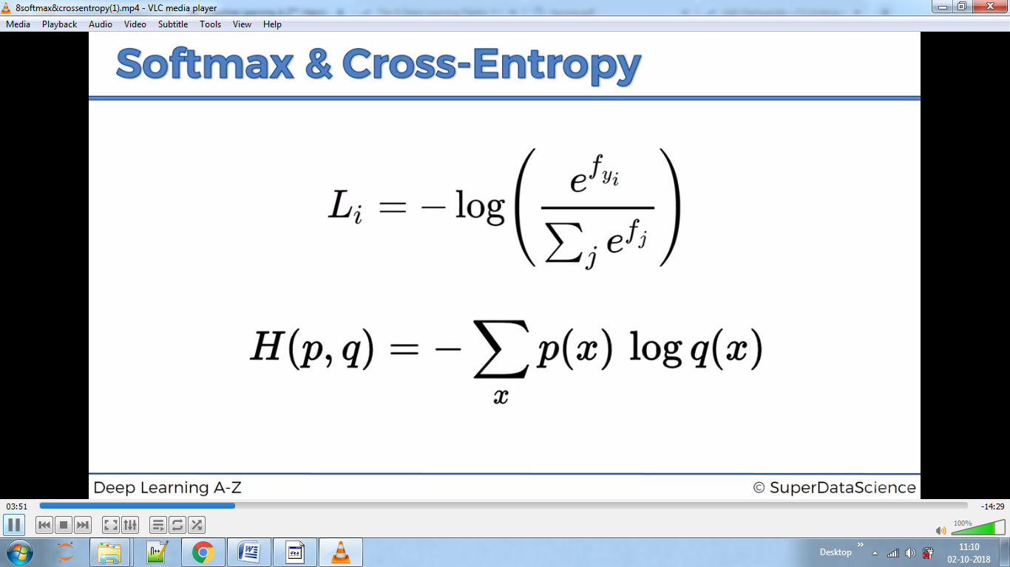

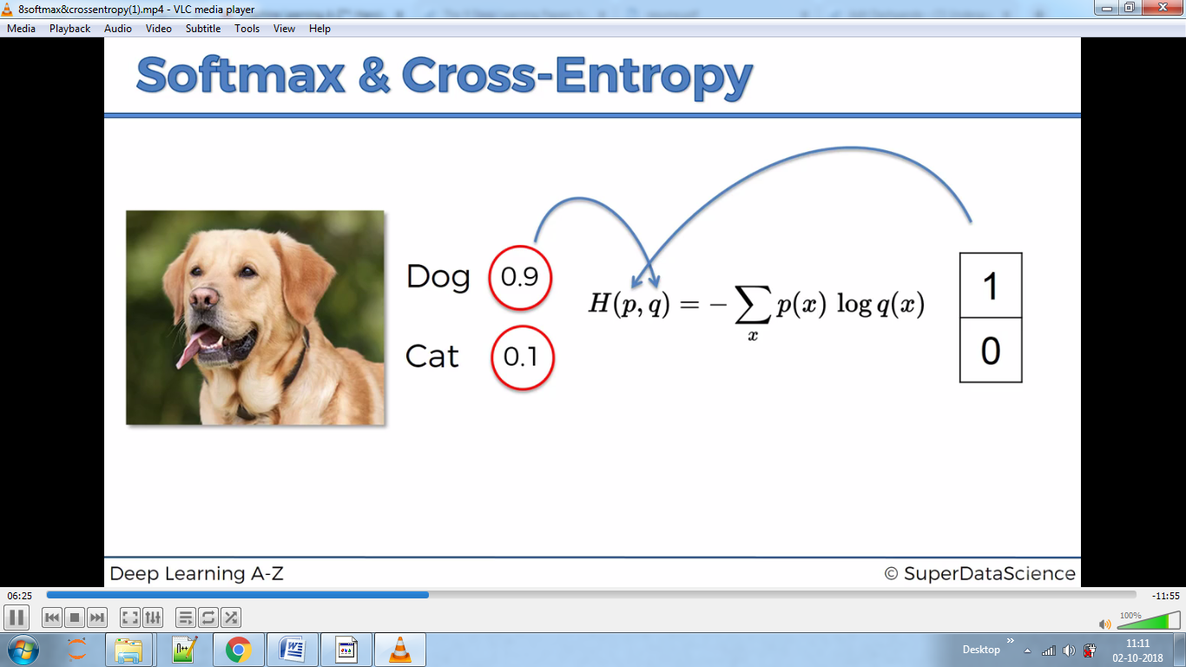

It outputs summation of above values

We want to classify images therefore we use convolutional on ANN.

Ways to initialise ANN ,sequential or graphs.

We use sequential.

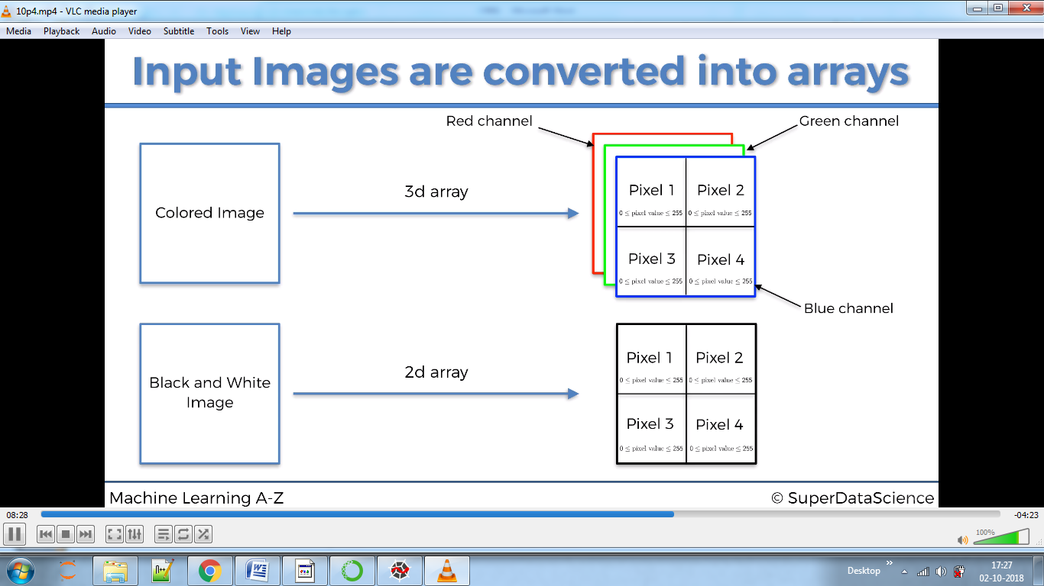

3d array for color image and 2d array for black and white.

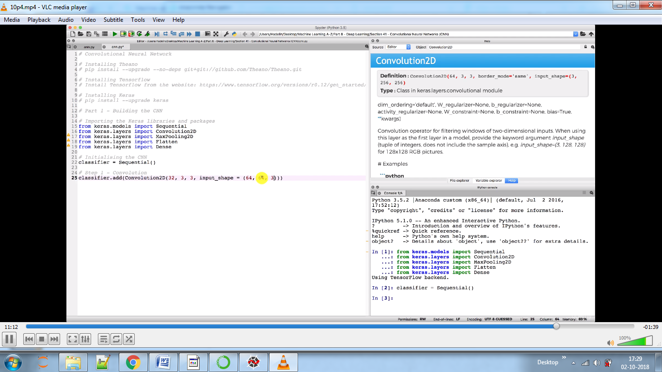

Here in convolution2d we specify 32 feature detectors with 3x3 Matrix size, input shape represents 3d array of 64x64 pixel, can be 256x256

Arguments there are for tensorflow backend,for theano backend we will use input_shape(3,64,64)

POOLING

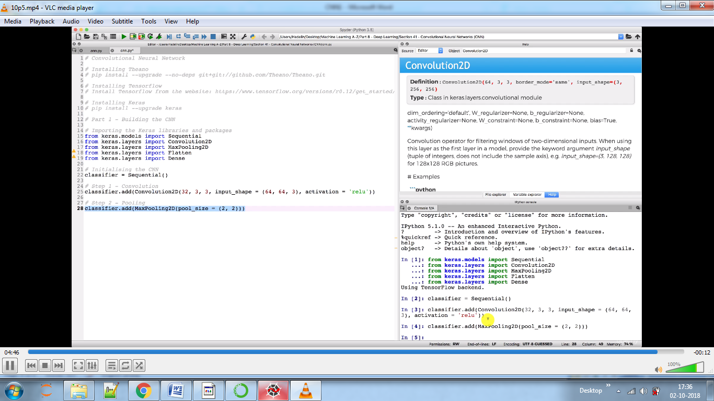

Here we are reducing complexity of our model without loosing any features.

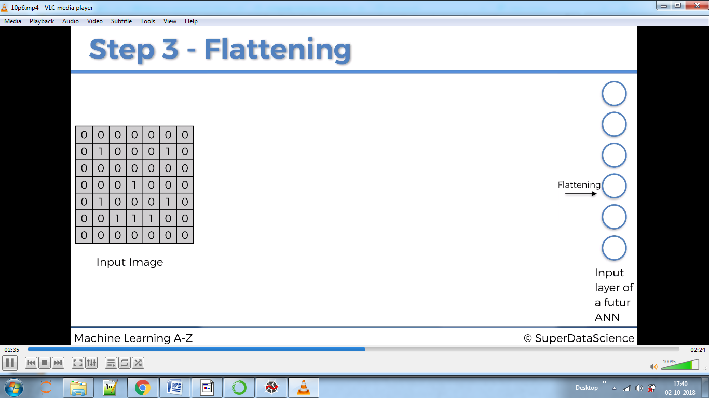

We don’t directly do above because here we won’t get relation between the pixels with each other; only get information about the individual pixel.

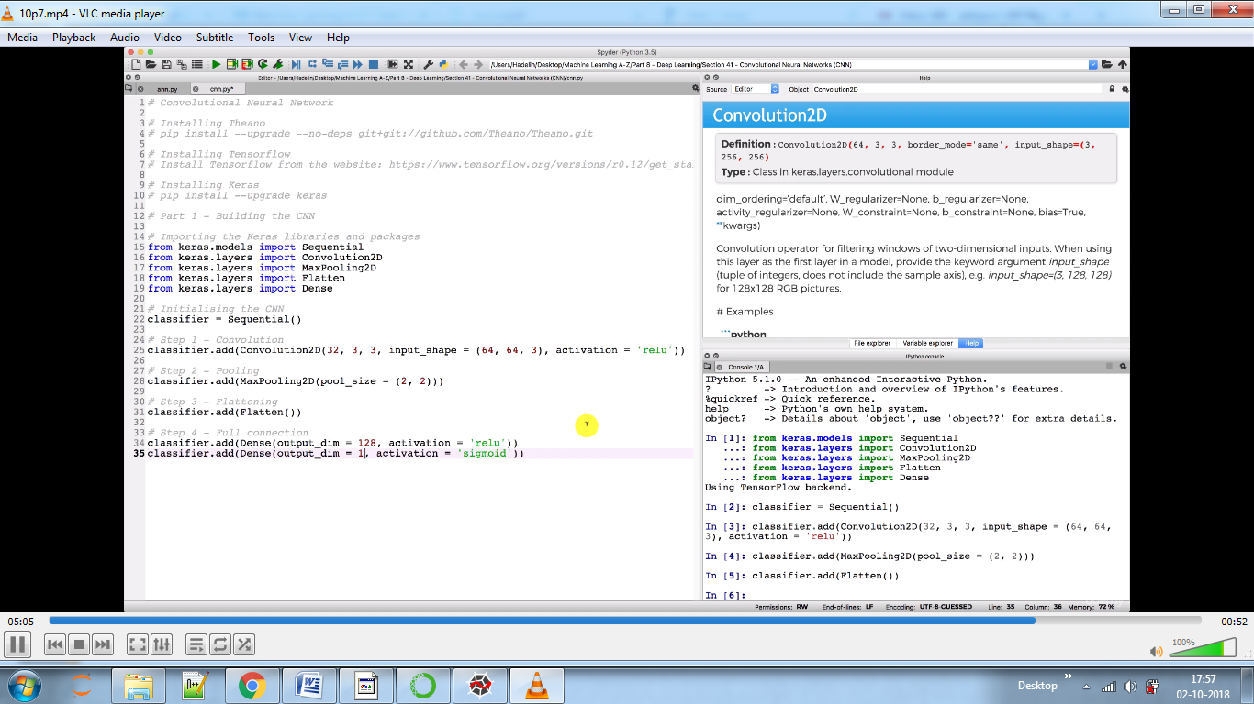

128 is no that can be put by experience, we usually put some power of 2.

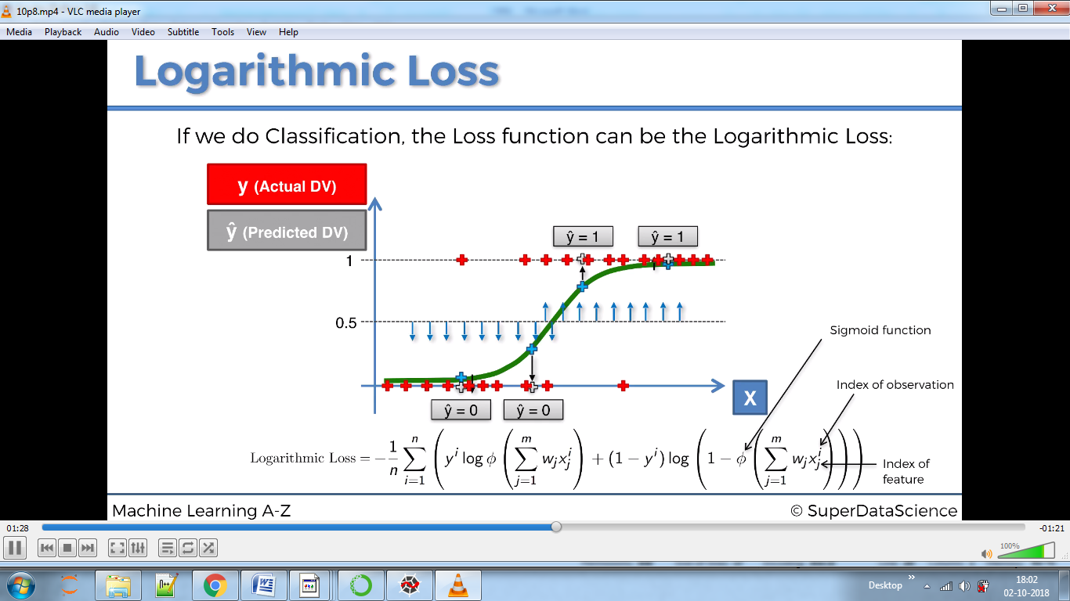

We use loss function as we have 2 output (cat, dog).We use categorical function if we have more than 2 categories.

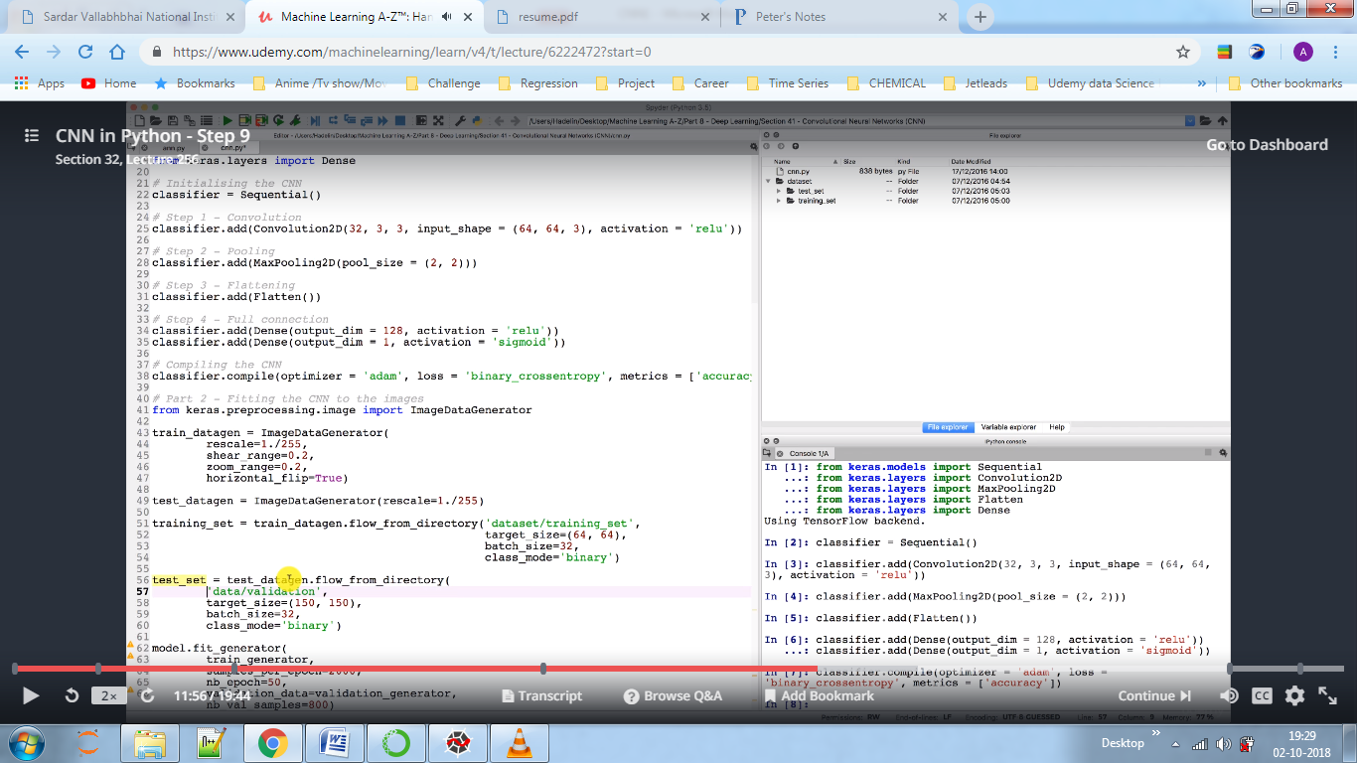

In datagen we rescale image to 0 to 1,shear range and zoom range are normal parameters,

In training set we set training size same as 64x64 and batch size as 32 images at a time,class_mode as 0 or 1 as we only have two variables.

We can improve the model either by adding fully convolutional layer or activaton layer by reducing overfitting.